# ReactJS-HOL

# Objectives

• Define SPA and its benefits

• Define React and identify its working

• Identify the differences between SPA and MPA

• Explain Pros & Cons of Single-Page Application

• Explain about React

• Define virtual DOM

• Explain Features of React

**What is SPA?**

SPA (Single Page Application) is a web application that loads a single HTML page and dynamically updates it as the user interacts.

**Benefits:**

* Faster performance
* Seamless navigation
* Reduced server load

## Define React and Identify Its Working

React is a JavaScript library used for building user interfaces, especially single-page applications (SPAs). It allows developers to create large web applications that can update and render efficiently in response to data changes.  
  
How React Works:  
- Component-Based Architecture: UI is divided into reusable components.  
- Virtual DOM: React uses a virtual DOM to compare changes and update only the parts that need to change.  
- Unidirectional Data Flow: Data flows from parent to child components.

## Differences Between SPA and MPA

|  |  |
| --- | --- |
| **SPA (Single Page Application)** | **MPA (Multi Page Application)** |
| Loads one HTML page; content updates dynamically | Loads a new HTML page for every interaction |
| Faster after first load | Slower due to full reloads |
| Smooth, app-like experience | Traditional web experience |
| More difficult to optimize | Easier SEO integration |
| Easier to manage with frameworks like React | More complex due to multiple pages |

## Pros & Cons of Single-Page Application

* Pros:
* Faster performance after initial load
* Seamless user experience with no full page reloads
* Reusable components using frameworks like React
* Ideal for mobile-like web apps
* Cons:
* SEO challenges, especially for content-heavy websites
* Initial load time can be longer due to loading full app
* Browser back/forward navigation needs manual handling
* Can be harder to secure without proper routing/auth setup

**What is React?**

* React is a **JavaScript library** for building **user interfaces**, maintained by Facebook. It uses components and a virtual DOM for fast rendering.

**What is Virtual DOM?**

* A **Virtual DOM** is a lightweight copy of the real DOM. It allows React to efficiently update only the parts of the page that changed, improving performance.

**Features of React**

* Component-based architecture
* Virtual DOM for fast rendering
* Unidirectional data flow
* Reusable components
* Support for testing
* Strong ecosystem and community

# Hands-on Lab Goals

• Set up a react environment

• Use create-react-app

# STEPS:

1. Step 1:

Install Node.js and npm from the official website: https://nodejs.org/en/download/  
Verify installation using:  
 node -v  
 npm -v

1. Step 2:

Install Create React App globally:  
 npm install -g create-react-app

1. Step 3:

Create a new React application named 'myfirstreact':  
 npx create-react-app myfirstreact

1. Step 4:

Navigate into the project folder:  
 cd myfirstreact

1. Step 5:

Open the project in Visual Studio Code:  
 code .

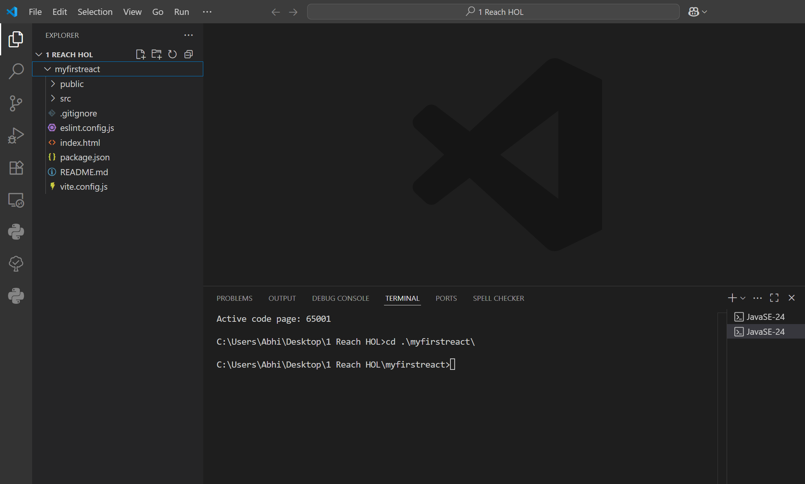

1. Step 6:

Edit App.js:  
- Open src/App.js  
- Remove existing content  
- Replace with:  
  
import React from 'react';  
  
function App() {  
 return (  
 <div>  
 <h1>Welcome to the first session of React</h1>  
 </div>  
 );  
}  
  
export default App;

1. Step 7:

Start the application:  
 npm start

1. Step 8:

Open your browser and navigate to:  
 <http://localhost:3000>

**OUTPUT:**

